\\zeus.diaserv.unisa.it\Profiles\cattaneo\Documenti\Immagini\cattaneoFT.tif 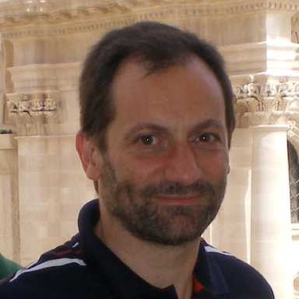

Giuseppe CATTANEO was born in Bari in 1960. In 1983 he took a Laurea degree cum laude in Scienze dell'Informazione from University of Salerno. From May 1986 to October 1999 he was associate researcher at Dipartimento di Informatica ed Applicazioni of the Università di Salerno. Since October 1999 he is associate professor at the same Department.

In 1987, with a post-graduate fellowship he visited the laboratory LITP of the University of Paris VI where he spent 3 years as Research staff Member investigating on Logical-Functional languages and their extensions toward parallelism. During this period he has developed on a Common-Lisp Machine a sub-system to enable explicit parallelism in the functional languages programming environmen introducing the necessary linguistic constructs.

From 1990 to 1993 his research activity was dedicated to the design and implementation of an Object Oriented Programming Language specialized to develop applications on massively parallel hardware (Actor Programming Language).

Since 1993 with professor F.G. Italiano, he started working on Algorithm Engineering. At the beginning he collaborated with an international group to design a common platform which should be used as test bed for experimental algorithm analysis. Successively he was involved in dynamic graph algorithms, implementing and comparing about 10 theoretical algorithms (to solve the problem known as Dynamic Connectivity and Minimum Spanning Tree) whose performance has been analyzed only from an asymptotic point of view. Starting from this studies, in the alcom-it EEC project, he realized a LEP (LEDA Extension Package for dynamic graphs) that is distributed over the net as LEDA companion package (MPI LEP Dynamic Graphs).

Since 2000 he developed many industrial projects, focusing on security aspects. Many of these led to the design and the implementation of real size prototypes used to perform an experimental evaluation of the global security of the proposed solution. Since 2006, with the SPEECH (Secure End-to-End Communications with Handhelds) project, security aspects have been merged with digital forensics, combining forensics analysis with software solutions able to increase the analyst capabilities to discover and produce digital evidence.

From December 2005 to June 2006 he was member of "Consiglio Superiore delle Comunicazioni" of Italian Ministry of Communications